**Project Report Template**

1. INTRODUCTION
   1. Overview

A brief description about your project

* 1. Purpose

The use of this project. What can be achieved using this.

1. PROBLEM DEFINITION & DESIGN THINKING
   1. Empathy map

Paste the empathy map screenshot

* 1. Ideation & brainstorming Map

Paste the Ideation & brainstorming map screenshot.

1. RESULT

Final findings (Output) of the project along with screenshot.

1. ADVANTAGES

List of advantages and disadvantages pf the proposed solution.

1. APPLICATION

The areas where this solution can be applied.

1. CONCLUSION

Conclusion summarizing the entire work and findings.

1. FUTURE SCOPE

Enhancements that can be made in this future.

1. APPENDIX
2. Source Code

Attach the code for the solution built.

**THE TRAGEDY OF FLIGHT: A COMPREHENSIVE CRASH ANALYSIS**

1. **INTRODUCTION**

An airplane crash analysis is a detailed investigation into the cause of an aviation accident. The goal of an airplane crash analysis is to identify any factors that contribute to the accident, with the ultimate goal of improving safety and preventing future accidents. The process of conducting an airplane analysis typically involves the collection and analysis of a wide range of data, including information about the aircraft and its systems, the operators, and any other relevant factors.

* 1. **OVERVIEW**

The analysis can provide closure to the families and loved ones of the victims of the crash, as well as to the broader public. It can also help to improve public confidence in the aviation industry by identifying and addressing any safety issues that may have contributed to the incident. The analysis can have significant business implications for the airline and aircraft manufacture involved in the incident. The airline may also face legal claims and reputational damage.

* 1. **PURPOSE**

The goal of an airplane crash analysis is to identify any factors that contributed to the accident, with the ultimate goal of improving safety and preventing future accidents. The results of an airplane crash analysis are typically published in a report, which may include recommendations for improving safety and preventing similar accidents in the future.

1. **PROBLEM DEFINITION & DESIGN THINKING**

**EMPATHY MAP**

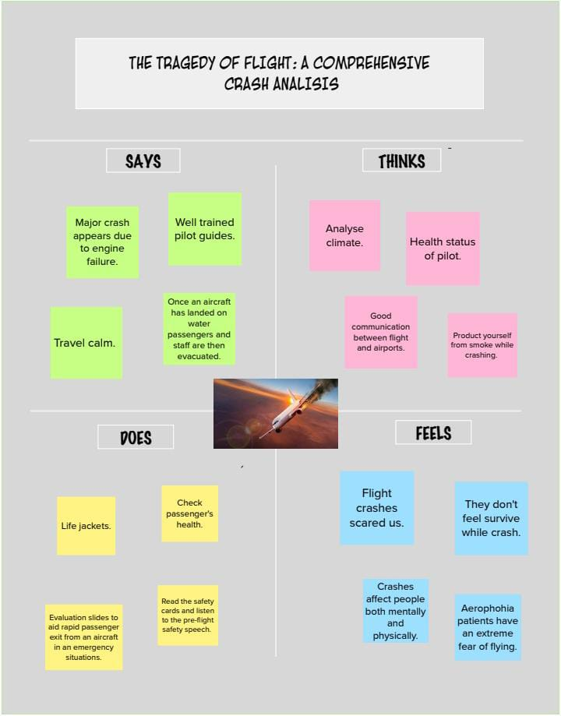

* 1. **IDEATION & BRAINSTORMING MAP**

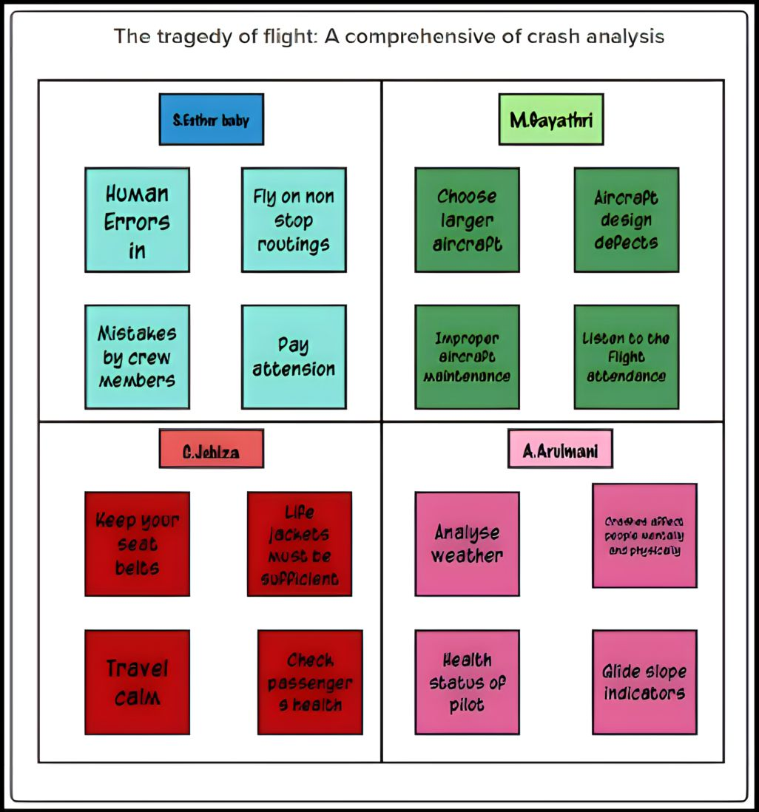**3. RESULT**

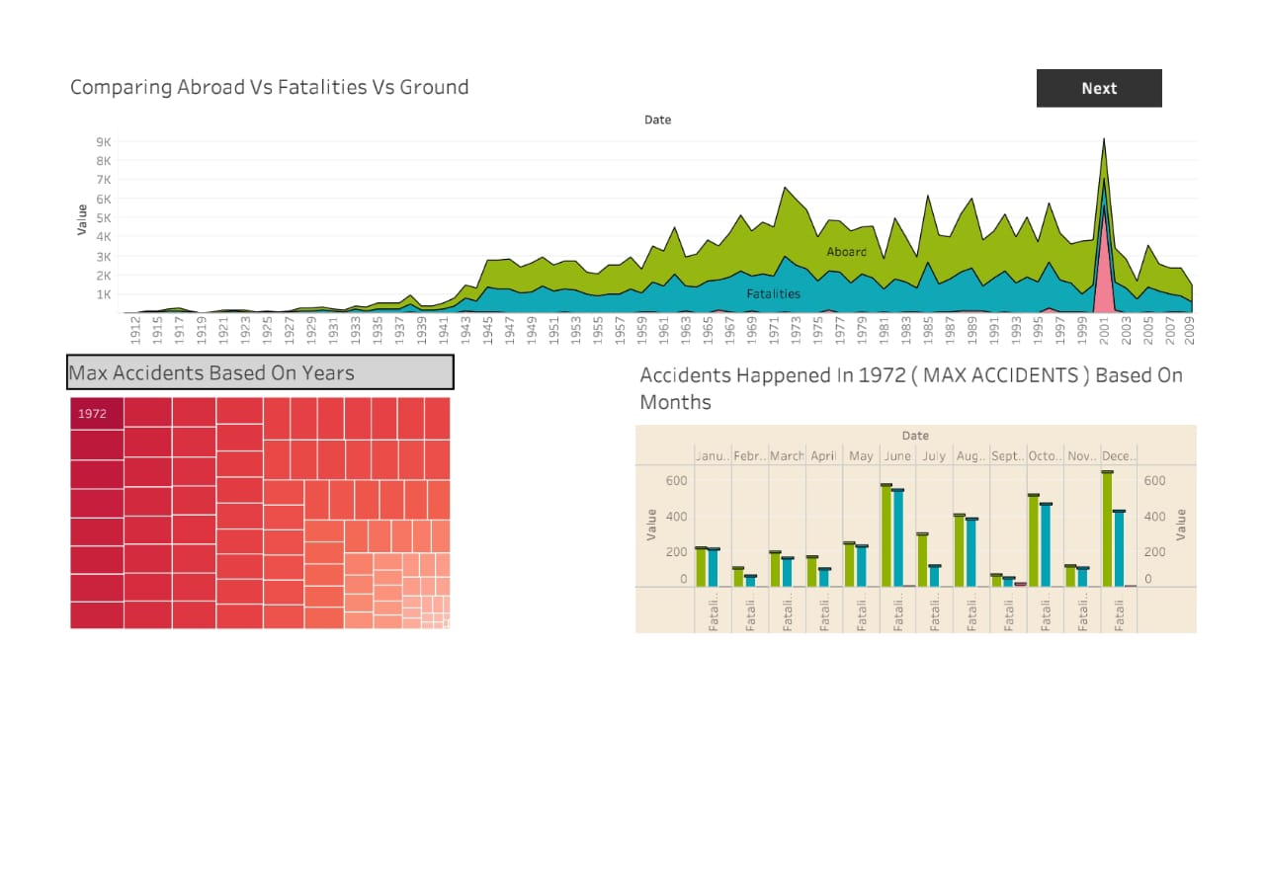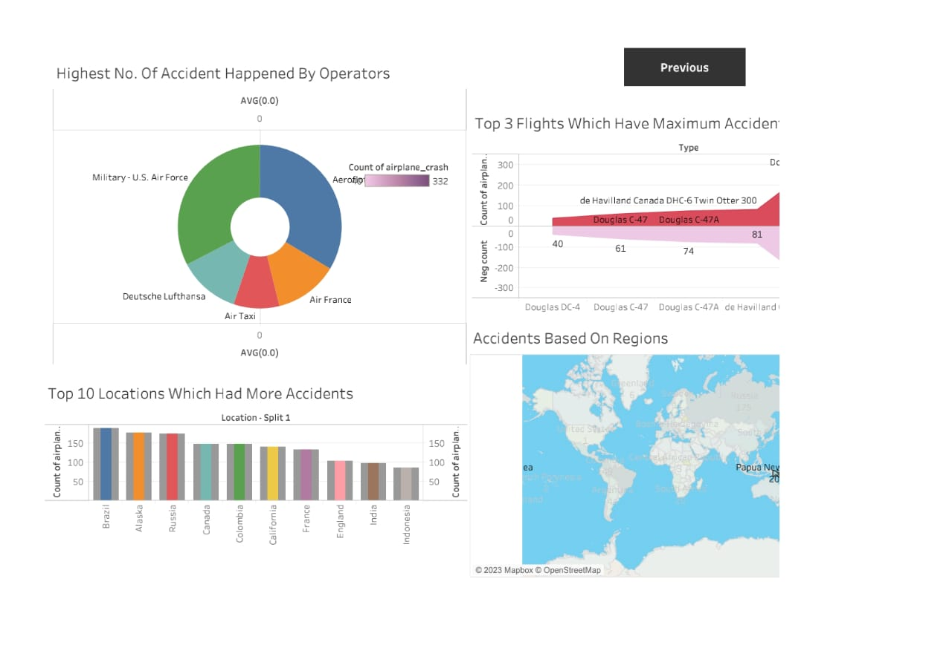

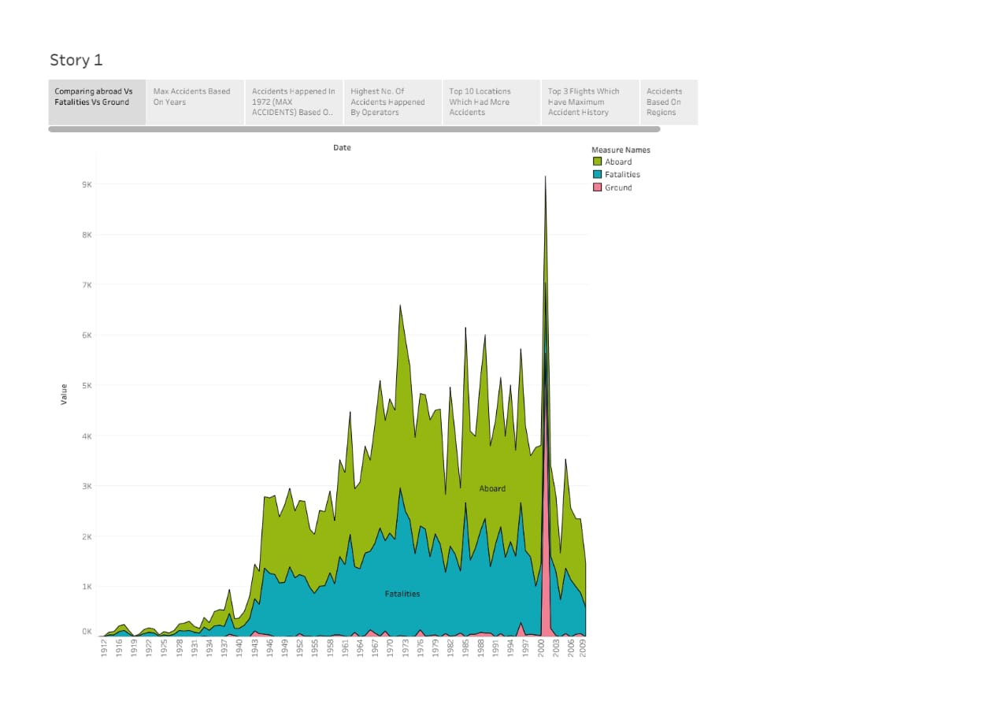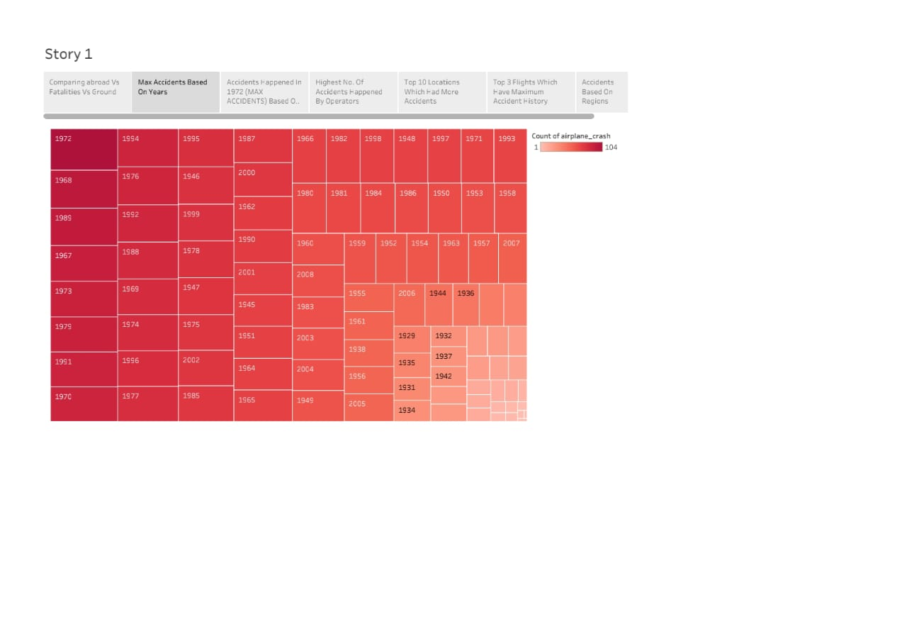

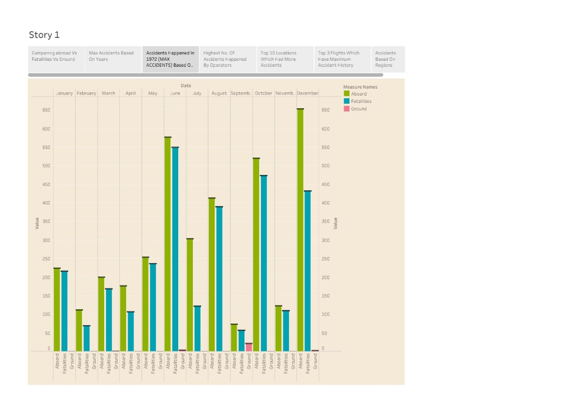

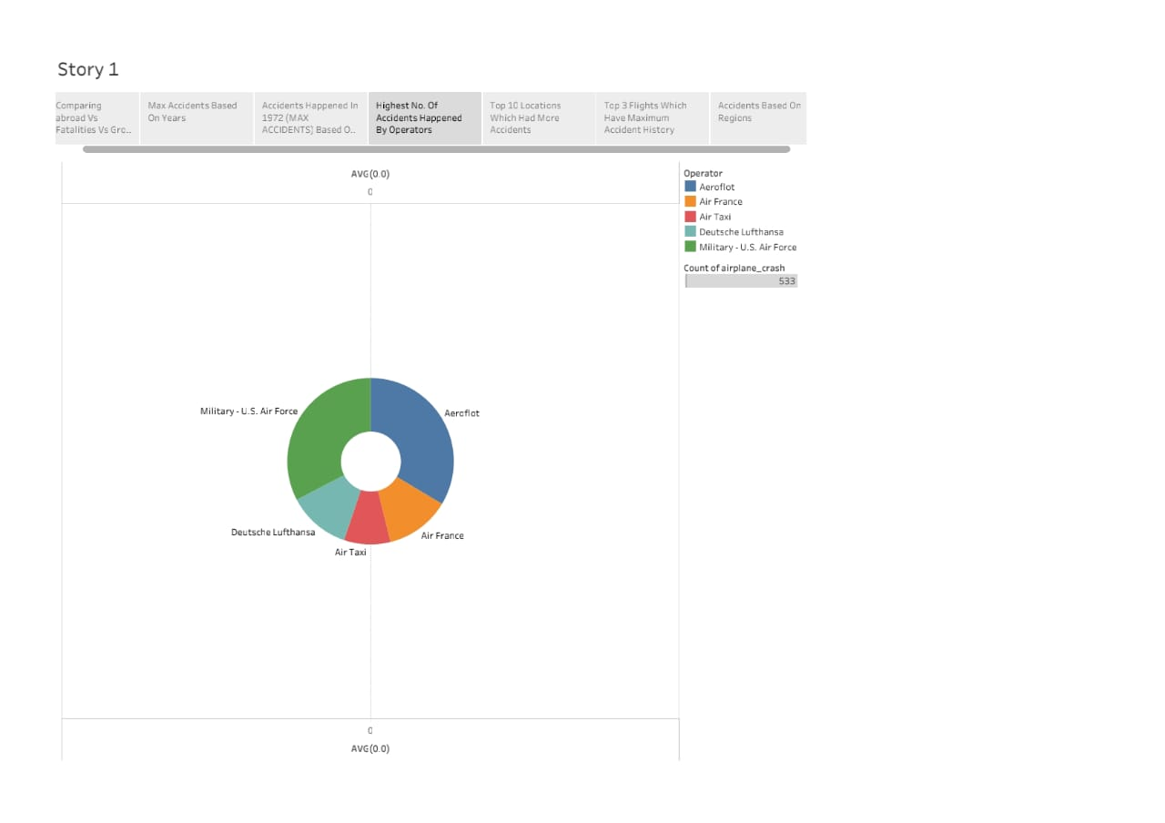

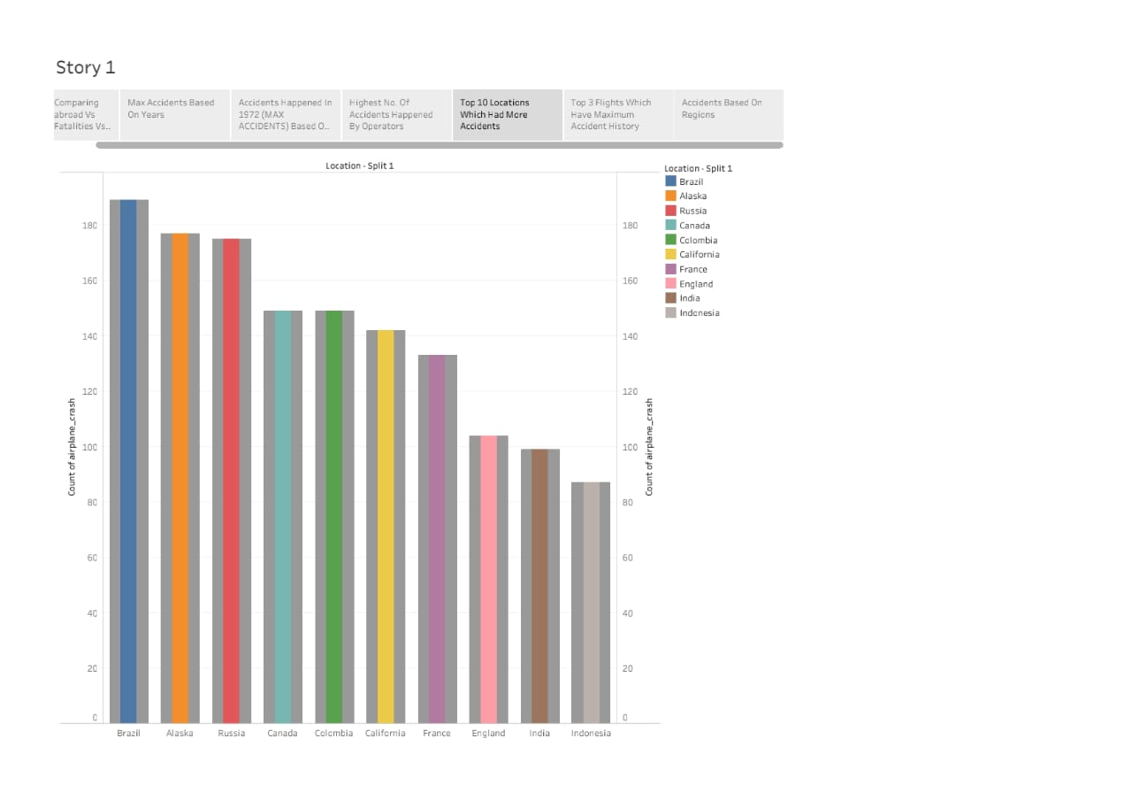

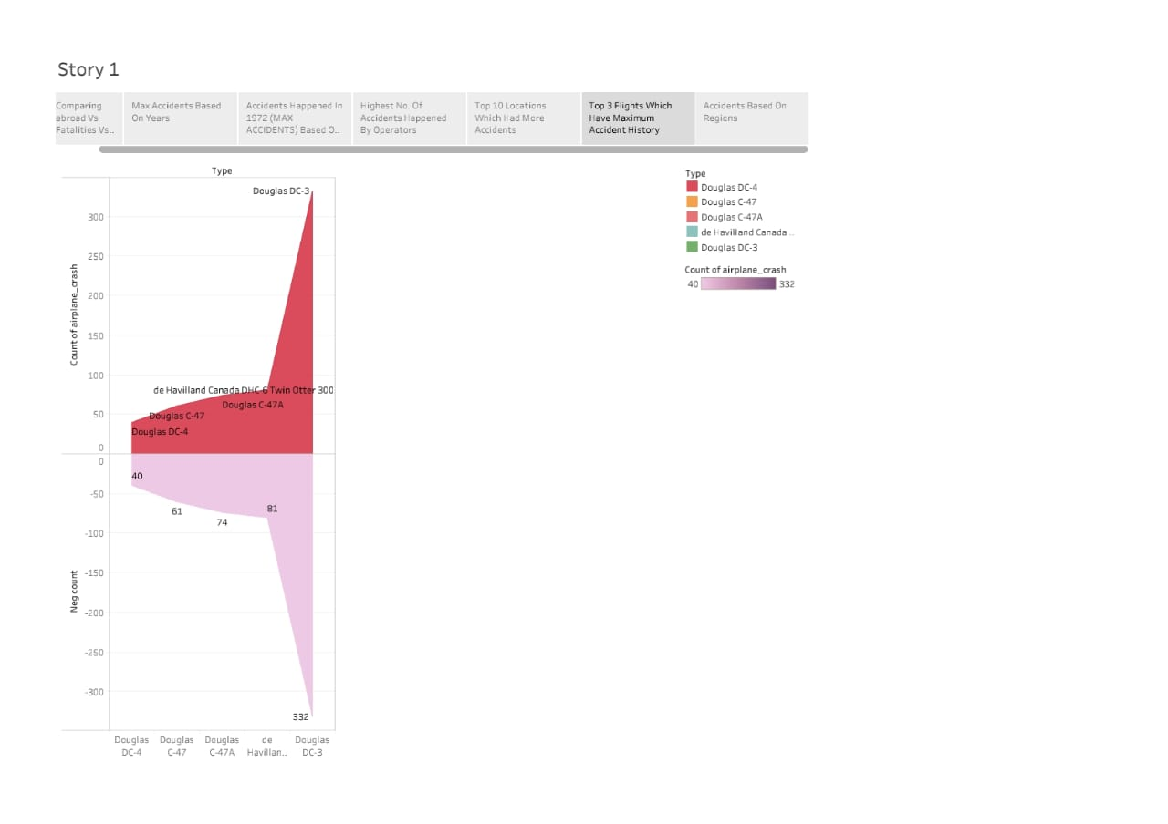

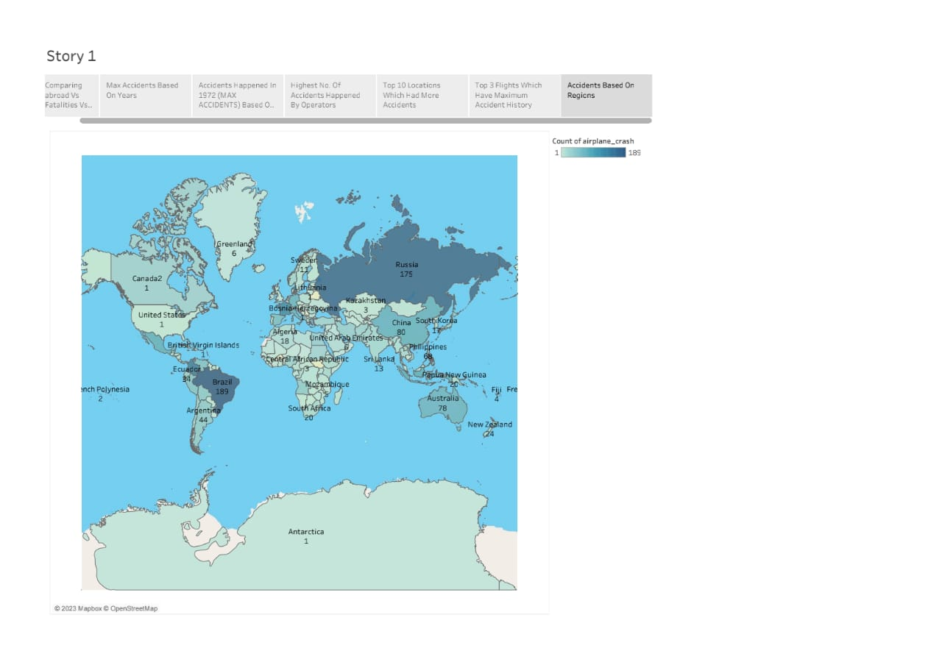

1. **ADVANTAGES & DISADVANTAGES**

***ADVANTAGES:***

* An aircraft can fly to any location without seeing any natural obstacles or barriers.
* Since customs formalities are easily compiled.
* It eliminates the need for more time to seek clearance.
* Air travel is used for relief operations during earthquakes, floods, accidents, and famines.
* It is considered the cheapest way to ship peregrinated goods.
* It offers a standard, convenient, reliable and fast service.

***DISADVANTAGES:***

* In many crashes the aircraft structure collapses and the individual is injured by impact with the airframe***.***
* These injuries can include amputations, major lacerations and crushing***.***
* When the structure collapses, the victims may become trapped within the wreckage and die of fire, drowning or traumatic asphyxia.
* Pilot error is the number one cause of aviation accidents. Piloting an aircraft requires lengthy training, a knowledge of the mechanical components of an aircraft, and hand-eye coordination skills to effectively and safely maneuver an aircraft. Pilots also have to think ahead.
* Especially in economy class and when flying with low-cost airlines, which makes us feel trapped and irritable.

1. **APPLICATIONS**

Evacuation slides, to aid rapid passenger exit from an aircraft in an emergency situation. Advanced avionics, incorporating computerized auto-recovery and alert systems. Turbine engines with improved durability and failure containment mechanisms. Landing gear that can be lowered even after loss of power and hydraulics. Measured on a passenger-distance calculation, air travel is the safest form of transportation available**.** "UK airline operations are among the safest anywhere. When compared against all other modes of transport on a fatality per mile basis, air transport is the safest - six times safer than travelling by car and twice as safe as rail."

1. **CONCLUSION**

The results of an airplane crash analysis are typically published in a report, which may include recommendations for improving safety and preventing similar accidents in the future. These recommendations may be implemented by the relevant authorities or industry organizations.

1. **FUTURE SCOPE**

Detailed information about the crash, including the date, time, location, and weather conditions at the time of the incident. A thorough analysis of the events leading up to the crash, including any mechanical failures or human errors that may have contributed to the incident. A review of the flight data and cockpit voice recordings to gather additional information about the events leading up to the crash. Interviews with the flight crew, passengers, and any witnesses.

1. **APPENDIX**
2. **SOURCE CODE**

file:///C:/Users/Admin/Desktop/BizLand/index.html